EXPERIMENT – 8

STUDENT FORM :
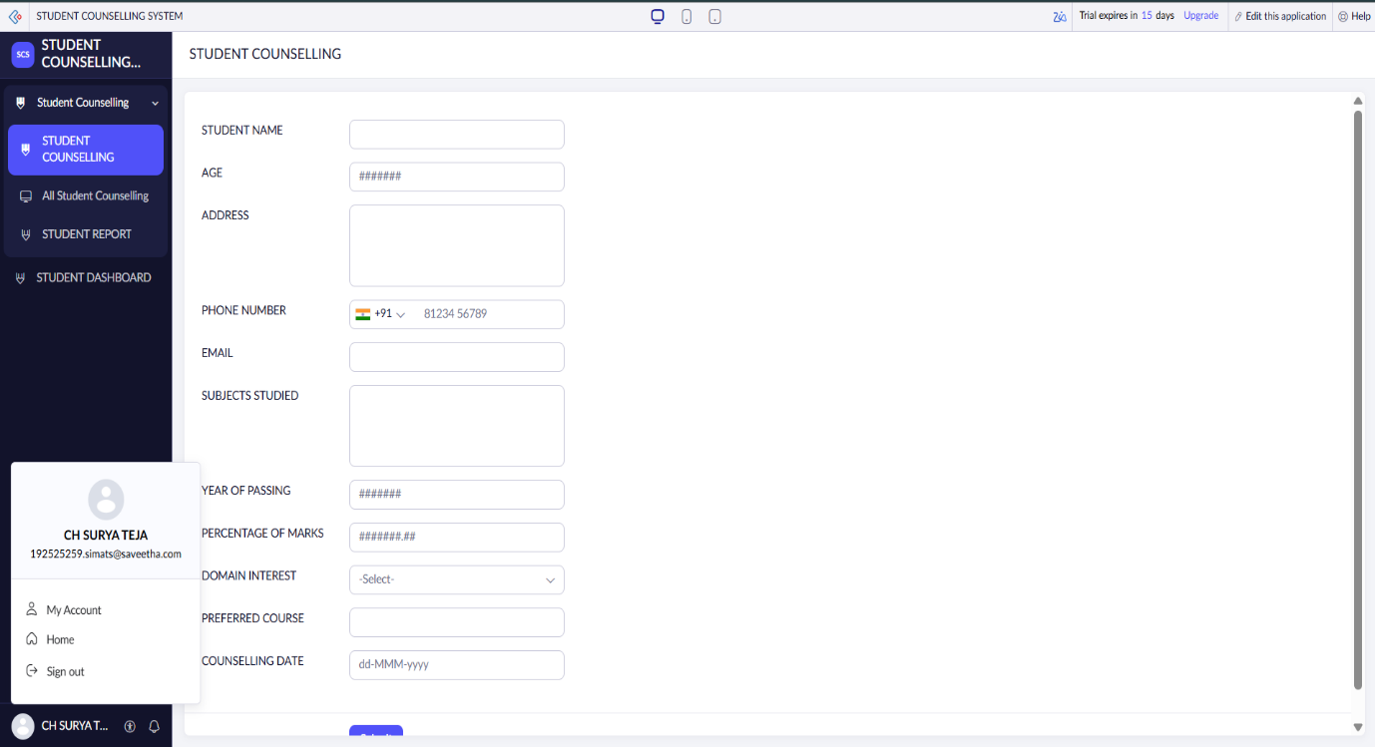
STUDENT REPORT :
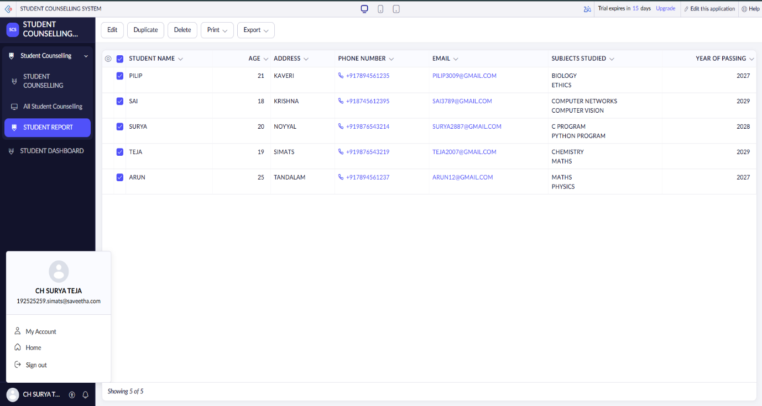

STUDENT DASHBOARD :
